The Best SeaArt Alternative for Anime AI Art
If you've spent any real time with SeaArt, you already know it's a capable anime AI generator. You're not here to ask what it is — you're here because something about your workflow has you looking for a SeaArt alternative: maybe you want stronger character consistency, more control over LoRA training, or a clearer sense of what your credits actually buy you.
I spent hands-on time putting PixAI head-to-head with SeaArt using the same prompts and the same kind of project a real creator runs — building an original character and trying to keep it consistent. This isn't a feature-sheet rewrite. It's what actually happened when I used both.
Short version: SeaArt is good, and I'll say where it's good. But if your work depends on the same character showing up again and again — across outfits, poses, and scenes — PixAI is the alternative I'd reach for, and the rest of this article shows why.

PixAI vs SeaArt at a glance
 | PixAI | SeaArt
Free plan | Yes — 10,000 daily credits | Yes — daily free credits ("Stamina")
Paid entry price | Starter $7.99/mo (billed annually) | Regular: $5.99 / $29.99 / $59.99 / $149.99/mo (Beginner/Standard/Pro/Master). Often promo-discounted (recently $4.79 / $16.49 / $30 / $67.50)
Per-image cost | Credit-based; generous free daily allotment | ~6 credits ≈ $0.006/image (SeaArt's figure)
Model variety | Full model + LoRA marketplace plus curated, anime-tuned base models (Tsubaki.2, Mio.2) built for multi-character & prompt-following | Very large library — SeaArt claims 1M+ models
Use existing LoRAs | Yes — up to 5 / 10 / 15 per generation by tier | Yes
Train your own LoRA | 3 full trainings/mo bundled free on Starter (5 Plus, 10 Premium) — no per-image cap (we trained 12 images at $0); integrated with Reference Pro | Yes, but metered by Stamina: free 130/day trains only ~3 images (Illustrious) / 7 (SDXL) — too few for a real character; a usable dataset needs credits or a paid tier. SDXL + Flux; publish & monetize
Character consistency tools | Reference Pro (reference-based gen) + Edit Pro (natural-language edits) — built around one stable character | Reference / ControlNet tools; "Prompt Magic"
Image editing / refine | Edit Pro — edit in chat with plain language | Editing tools + Quality Mode (SVIP)
Speed | Turbo Mode (unlimited fast) on paid tiers | Standard / Quality modes; ~10× faster for SVIP
API / automation | Yes — public GraphQL API (api.pixai.art); script generations and even apply your own trained LoRA programmatically | Yes — developer REST API available
Commercial use | You own the art you generate and may use it commercially (PixAI grants ownership to the creator) | You own your generated content and commercial use isn't prohibited — but the free plan carries no explicit commercial rights; a paid tier is recommended for clear commercial licensing (and third-party rights still apply)
Community & creators | Active community + model sharing | Large community, marketplace, AI agents, AI characters
If you just wanted the quick answer, that's it. The detail below is where the table turns into a real decision.

Why character consistency matters more than one great image
Here's the thing most "best AI art generator" comparisons miss: getting one stunning image is easy now. Both PixAI and SeaArt will hand you a gorgeous anime render on the first try. I ran the exact same prompt on both —
masterpiece, best quality, 1girl, original character, long silver hair with cyan tips, amber eyes, navy futuristic jacket with glowing teal accents, fingerless gloves, confident slight smile, upper body portrait, cinematic studio lighting, highly detailed anime illustration
— and both produced a polished, on-prompt character.
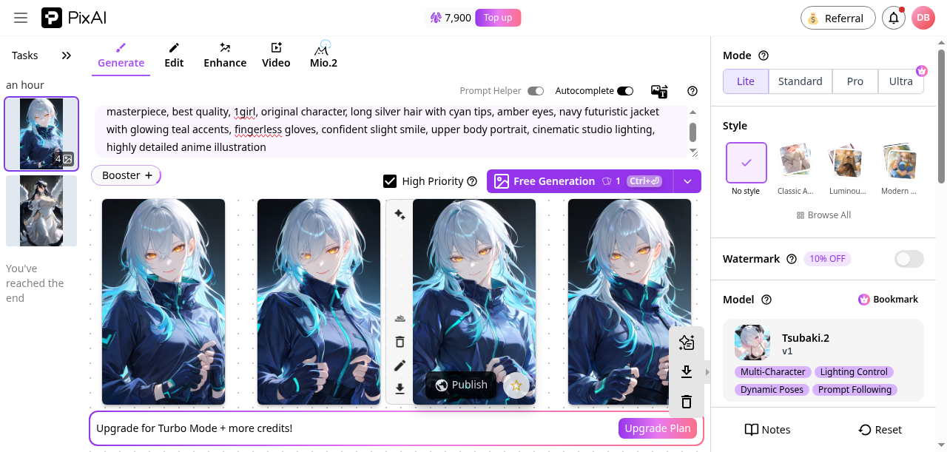 | 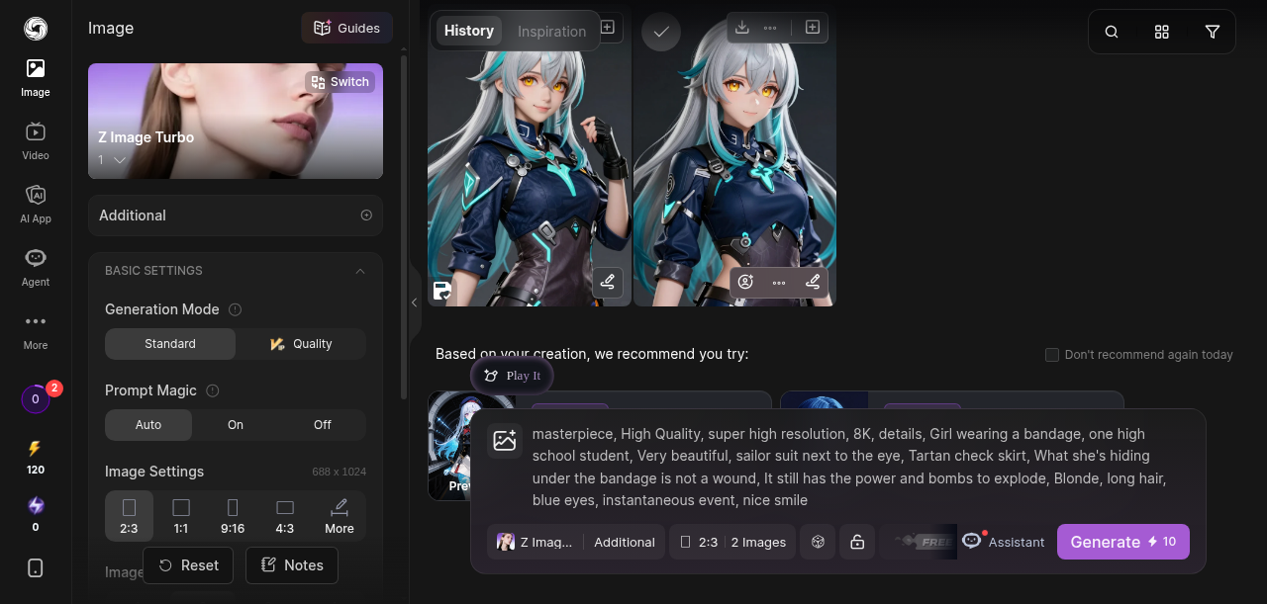
Figure: Left: PixAI (Tsubaki.2) . Right: SeaArt (Z Image Turbo) . Caption: identical prompt, both platforms, free tier — both nail a single image
So if you only ever need one picture, honestly, flip a coin. But that's not how most serious creators work. If you're building an original character (OC), running a VTuber project, making visual-novel art, or posting a steady stream of social content, you don't need one good image of your character — you need the same character, fifty times, in different outfits, poses, and moods, without the face drifting into a stranger every generation.
And that is exactly where prompting alone breaks down. Re-run the same description and you get a theme, not an identity — the silver hair and amber eyes come back, but the face is subtly (or not so subtly) a different person each time. Solving that is the real test, and it's where these two platforms diverge.

LoRA training, not just LoRA use
Both platforms let you apply existing LoRAs. The bigger question for character work is whether you can train your own — teach the model your specific OC so it reproduces them reliably.
On PixAI, training your own LoRA isn't a bolt-on — it's a first-class feature, and I trained one end-to-end to see how it actually feels. Here's the real workflow I ran for an original character (call her "Aoi" — silver hair with cyan tips, amber eyes, a navy cyber jacket):
1. Design the character with a prompt. I wrote one detailed description and generated a batch on PixAI's standard generator. Text-to-image alone gets you a consistent design but not a locked identity — the jacket and hair come back every time, but the face drifts subtly from image to image. That drift is the whole reason to train a LoRA.
2. Build a small dataset. I curated ~12 images of Aoi across front, three-quarter, and side views. PixAI's trainer lets you pull straight from your generation history — no re-uploading, no leaving the browser. (Minimum 10 images; up to 100.)
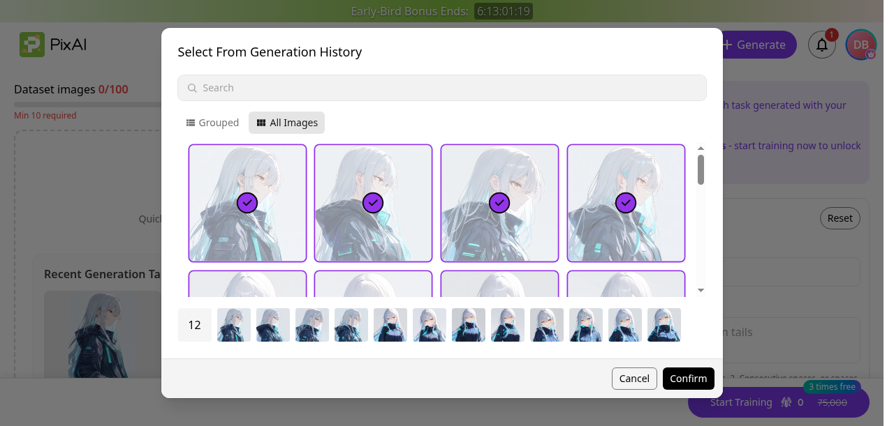
Figure: 12 OC images selected directly from generation history
3. Set it up and train. Name the LoRA, give it a trigger word (aoicyber), pick a category and a base model (I used Illustrious-v1.0), and hit train. No notebooks, no command line, no GPU rental — the whole thing is a form in the browser.
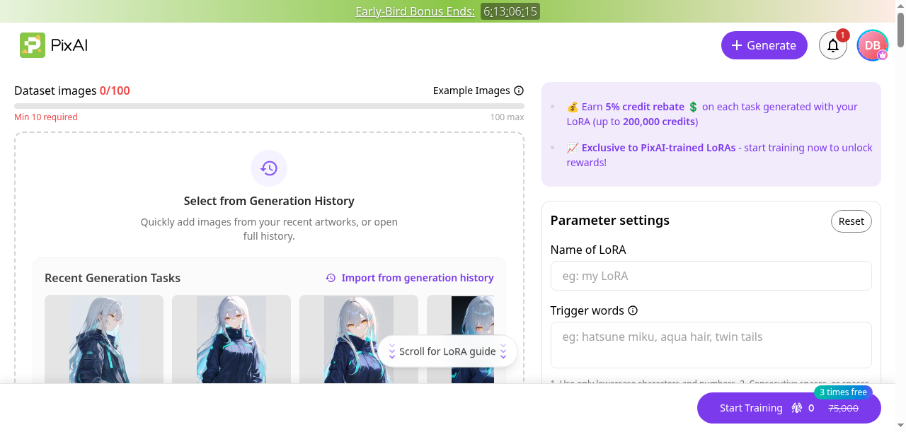 | 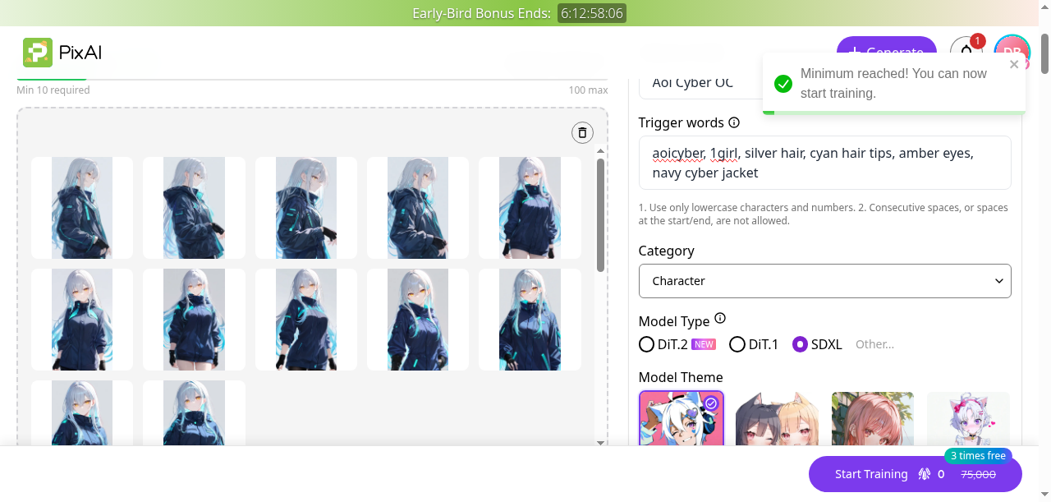
Figure: and — the in-browser training form: dataset, trigger words, category, base model
The part that matters for cost: LoRA training is included free with membership — 3 trainings a month on Starter ($7.99), 5 on Plus, 10 on Premium. On the entry tier my training run cost zero credits (PixAI even offers a small ongoing credit rebate when others generate with your LoRA). For a creator whose whole goal is one repeatable character, that single inclusion can outweigh the subscription on its own.
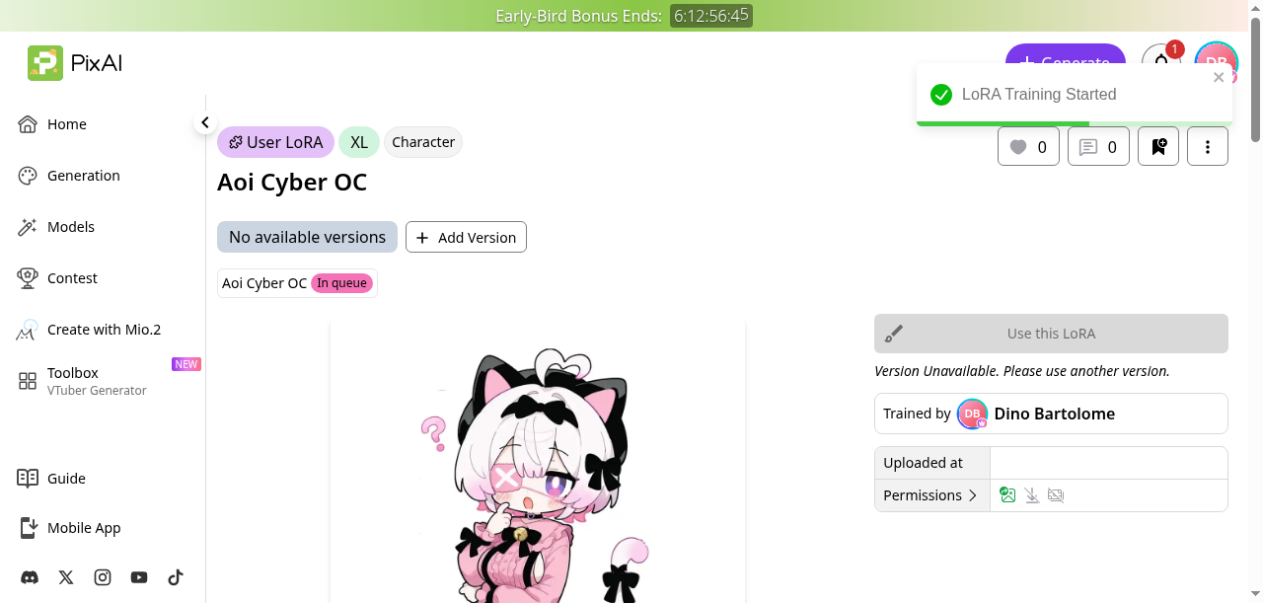
Figure: "Aoi Cyber OC", a User LoRA queued for training, free
Once trained, you invoke the character by dropping its trigger word into any prompt — and that's where consistency stops being approximate and starts being reliable.
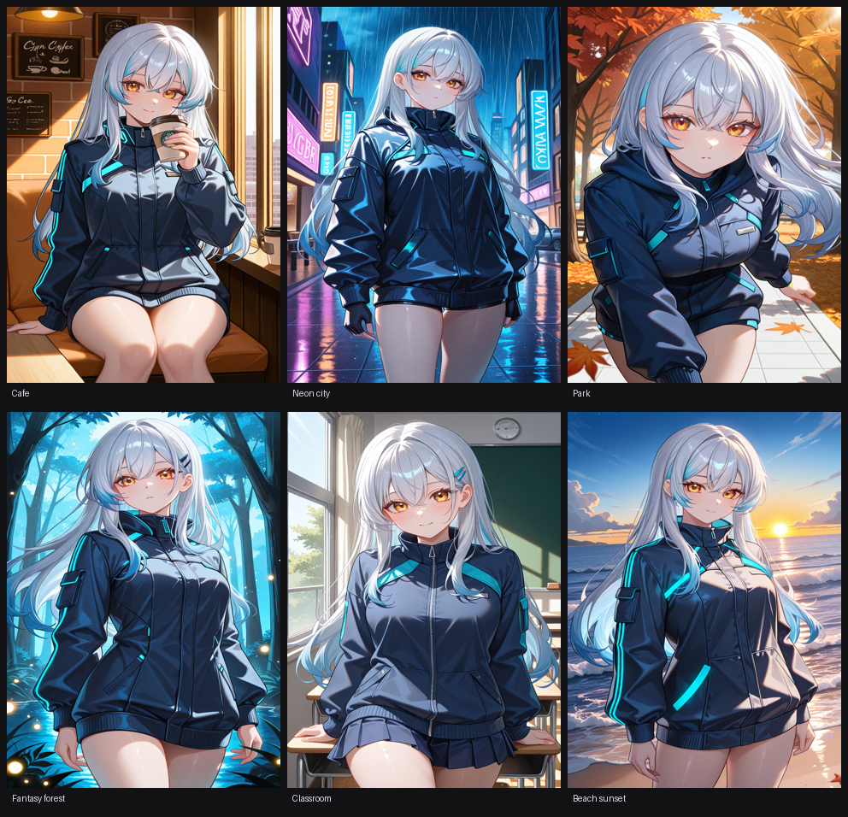
Figure: the same Aoi across six settings she was never trained in (cafe, neon city street, autumn park, fantasy forest, classroom, beach sunset), all via the aoicyber trigger. Same silver-with-cyan hair, amber eyes, and navy cyber jacket every time. This is the article's strongest single visual: text-to-image gives you a look; the trained LoRA gives you the same character, project after project
And it holds up the further you push it — here's the same OC again across eight more unrelated scenes, including outfit changes:
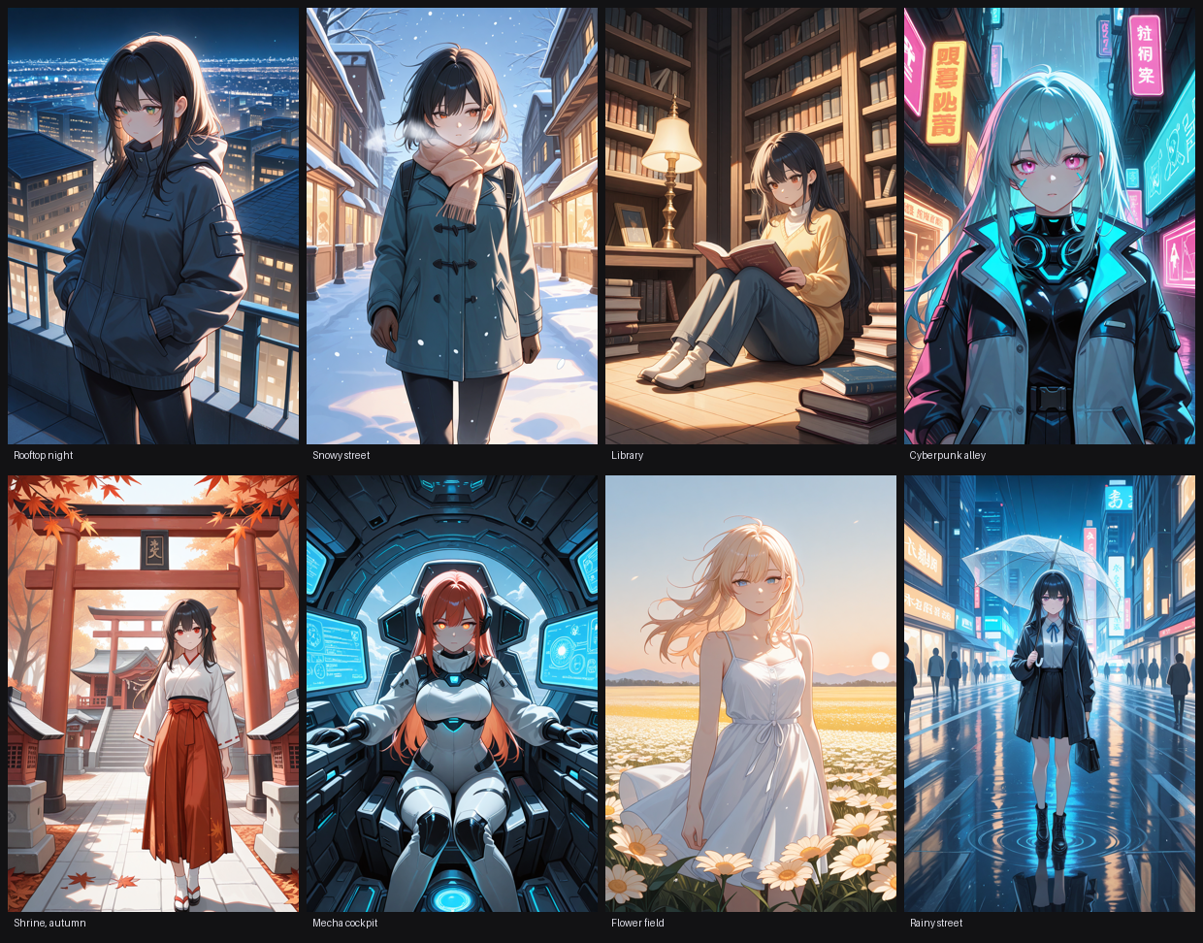
Figure: Aoi across a rooftop at night, a snowy street, a library, a cyberpunk alley, an autumn shrine, a mecha cockpit, a flower field, and a rainy street. The face, hair, and signature jacket stay recognizably her even as the wardrobe and setting change completely
And to be fair to SeaArt, it also offers on-platform LoRA training — a capable setup with a wide choice of base models (SDXL, Illustrious, Pony, Flux and more), trigger words, and epoch/repeat controls.
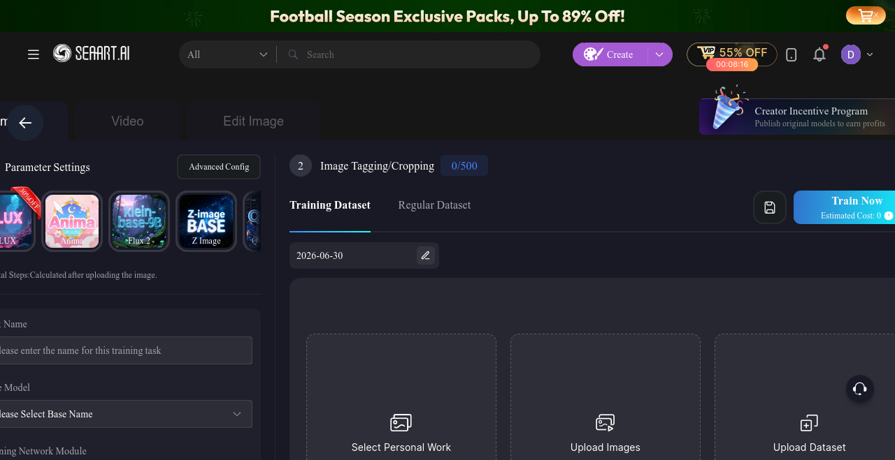
Figure: SeaArt's Image LoRA training setup: base-model picker, dataset upload, and tagging
But here's where the value gap gets concrete. On SeaArt, training is metered by Stamina. A free account gets 130 Stamina a day, and by SeaArt's own numbers that buys you a dataset of only about 3 images on an Illustrious or PONY model, 7 on SDXL, or 2 on Flux. SeaArt's own help article puts it plainly: "few images can be set, so training may be difficult." Three images is nowhere near enough to teach a model your character — for that you want 15–30. So to train a usable character LoRA on SeaArt, you end up buying credits or stepping up to a paid tier; the "free training" exists, but in practice it's a teaser.
Now compare that to what PixAI's Starter plan actually includes for $7.99/mo: three complete LoRA trainings every month, free, with no per-image Stamina tax. My Aoi LoRA trained on 12 images and cost me zero credits — and I still had two more free trainings left that month. Starter also bundles the Reference Pro and Edit Pro tools you use to build that consistent dataset and refine results, plus Turbo Mode, the video suite, a +20% daily-credit bonus, and 300,000 monthly credits. That's a genuinely generous entry tier: the single feature most likely to justify the subscription — real, repeatable LoRA training — is included, not metered.
So the honest scorecard: SeaArt has the lower sticker price to dabble and a famously huge model catalog; PixAI's Starter is the better deal the moment you actually want to train and reuse a character, because the training is included in full and wired into the consistency workflow rather than rationed by the day.

Creative flexibility, not just output quality
Because both platforms produce good-looking anime images, quality alone rarely decides it — flexibility does.
In testing, PixAI's generator surfaces the levers a character-focused creator actually uses: model choice (Tsubaki.2 is tuned for multi-character scenes, lighting control, and prompt-following), quick mode switching (Lite → Standard → Pro → Ultra) to trade speed for fidelity, style presets, and an editing path (Edit Pro) so you can refine a result instead of re-rolling from scratch.
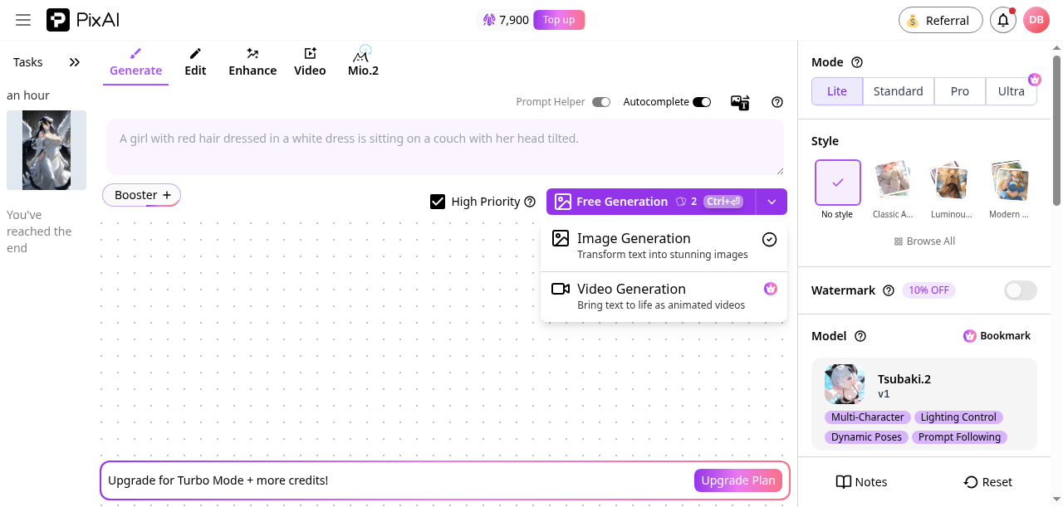
Figure: modes, style picker, model panel with multi-character/lighting/dynamic-pose tags
And for power users, PixAI exposes a public GraphQL API — in fact, the eight extended scenes above were generated through it, calling my own trained LoRA on each request rather than clicking through the UI. SeaArt offers a developer REST API too, so both reward automation; the difference that mattered to me is that PixAI's API lets you drop your trained character straight into scripted, repeatable generation — the same consistency advantage, now hands-free.
SeaArt counters with real breadth: a deep model/checkpoint library, Standard vs Quality generation modes, Prompt Magic, plus community features like a marketplace and AI agents.
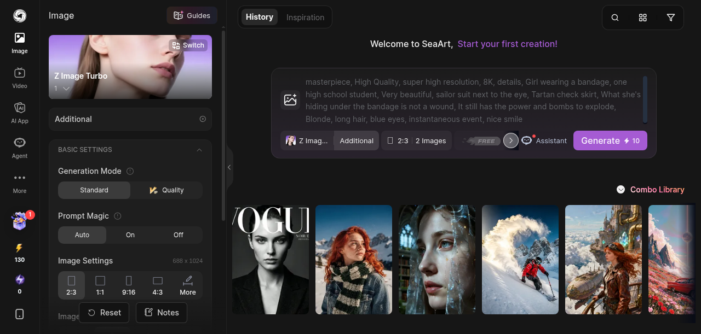
Figure: generation modes, prompt magic, image settings, base model
The difference I felt wasn't "one is better" — it's what each optimizes for. SeaArt feels built around a sprawling community and a huge catalog to explore. PixAI feels built around taking one character and carrying it through a whole project. If you're a long-term OC or VTuber creator, that second framing is the one that compounds.

Editing and refining: fix it, don't re-roll it
When a generation comes out almost right — the expression's off, an outfit detail is wrong, a hand needs fixing — the beginner move is to re-roll and hope the next one is better. The problem is that re-rolling a character you care about often hands you a slightly different character. The professional move is to edit.
This is where PixAI's Edit Pro earns its place: you describe the change in plain language — "change the jacket to red," "give her a soft smile," "remove the background" — and it applies the edit in place, keeping the face and composition you already liked. SeaArt has editing tools too, and its Quality Mode (on SVIP) sharpens detail nicely. But the distinction that matters for character work is preservation: PixAI's edit flow is built to keep your subject intact while you adjust everything around it. When that subject is an OC you spent real effort making consistent, "edit, don't re-roll" stops being a tip and becomes the whole workflow.

Value: what you actually get for the price
Don't compare on sticker price alone — compare on what the price unlocks.
PixAI's Free plan is genuinely usable: 10,000 daily credits, enough to experiment and generate every day at no cost. Stepping up to Starter at $7.99/mo (billed annually) adds a +20% daily credit bonus, 300,000 monthly credits, unlimited Turbo Mode, the video suite, Reference Pro/Edit, and — critically for character work — 3 free LoRA trainings a month. Plus ($22.99) and Premium ($35.99) scale the credits, bonuses, and LoRA allotments up from there.
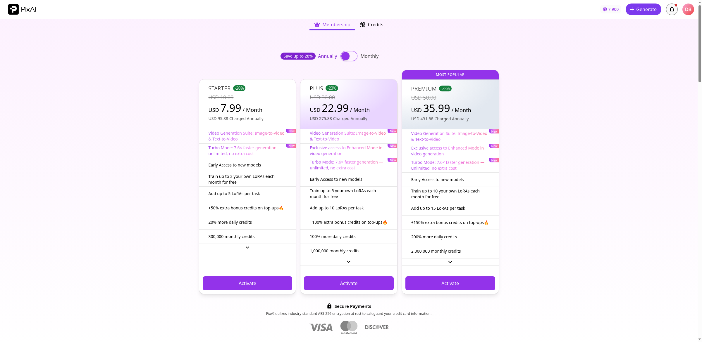
Figure: > Figures above are from PixAI's official membership material (pixai-membership-reference.txt). [FIGURE: PixAI pricing]
SeaArt prices aggressively too, and credibly so: a free plan with daily credits, paid SVIP tiers running from roughly $4.79/mo (Beginner) through Standard (~$16.49), Pro (~$30), and Master (~$67.50), with generation costing about 6 credits — ~$0.006 — per image and a famously huge model catalog (SeaArt cites 1M+). On raw price-per-image and sheer catalog size, SeaArt is hard to beat, and its paid tiers add a high-quality mode and roughly 10× faster generation.
So the value question isn't "which is cheaper" — at these prices both are inexpensive. It's what the money is organized around. SeaArt optimizes for volume and variety: lots of models, lots of images, cheaply. PixAI optimizes for one character, done well, repeatedly — its entry tier bundles the LoRA training and the Reference Pro / Edit Pro tools that keep that character consistent, in a single subscription. For a creator whose work is a recurring OC or VTuber rather than a stream of one-offs, that bundling is where PixAI's $7.99 quietly out-values a pile of cheap individual generations.

Built for the long haul: OCs, VTubers, and visual novels
Most AI-art comparisons judge a tool on a single generation. But the creators this article is really for don't work in single generations — they work in projects that run for months, and that's where a consistency-first platform compounds. Picture the four creators most likely to be reading this:
- The OC artist. You design your character once, train a LoRA, and from then on every new outfit, pose, and expression is the same person — not a cousin who happens to share a hair color. A year of artwork that genuinely looks like one character, because it is.
- The VTuber. Emotes, stream thumbnails, channel art, merch — all of it has to stay on-model, week after week. A trained LoRA is your character on tap. On SeaArt, the per-Stamina training cost makes that a recurring tax; on PixAI's Starter, it's a bundled, repeatable feature.
- The visual-novel maker. A VN needs a whole cast — five or ten characters who stay recognizable across hundreds of scenes and expressions. Train one LoRA per character, and your pipeline becomes "write the scene, generate the cast," instead of "re-roll and pray the faces line up."
- The daily poster. A recognizable mascot, posted every day, is a brand. Drift kills it; consistency builds it.
SeaArt genuinely supports one-off project work and gives you an enormous catalog to explore along the way. But over weeks and months, the platform that lets you lock a character and reuse it — for free, as part of your plan — is the one that keeps paying you back. For long-term character work, that's PixAI.

Who should pick which
- Choose SeaArt if you love exploring an enormous model catalog and a busy community, and most of your work is one-off images where each piece stands alone.
- Choose PixAI if your projects live or die on character consistency — an OC across a whole series, a VTuber's evolving art, visual-novel casts, or a steady social feed where the same character has to show up over and over. The LoRA-training + Reference Pro workflow is built for exactly that, and it starts at $7.99 — or free while you test the waters.
Neither is a bad tool. But if you came here looking for a SeaArt alternative because consistency, LoRA training, and long-term character work matter to you, PixAI is the one I'd point you to.

SeaArt alternative: frequently asked questions
Is PixAI a good alternative to SeaArt?
Yes — especially if you care about character consistency and training your own LoRA. Both are anime-focused generators, but PixAI bundles free LoRA training and reference-based tools into its entry tier, which is exactly what you need to build and reuse a character.
Which is better for keeping a character consistent?
PixAI, by a clear margin for serious projects. Its trained-LoRA plus Reference Pro workflow holds a character's identity across scenes — we generated the same OC across fourteen different settings without the face drifting. SeaArt can train LoRAs too, but its free tier caps the dataset at roughly 3–7 images, which is too few for a reliable character.
Which gives better value for money?
For one-off images and browsing a massive model catalog, SeaArt's per-image price is hard to beat. For training and reusing a character, PixAI's $7.99 Starter — with free monthly LoRA training included — out-values it, because the feature you'd actually pay for is already in the box.
Can PixAI replace SeaArt for my workflow?
If your work centers on a recurring OC, a VTuber, or a visual-novel cast, yes. If you mainly explore an enormous library for standalone images, SeaArt's catalog is a real strength — plenty of creators happily use both.
Are there other sites like SeaArt?
There are several anime AI generators worth a look, but for the specific combination of free LoRA training, reference-based consistency, and an integrated editing workflow, PixAI is the alternative to SeaArt we'd put at the top of the list.

Try it yourself
The fairest way to judge a SeaArt alternative is to run your own character through it. PixAI's free plan lets you do that today — 10,000 daily credits, no payment needed — and if you want to train a LoRA on your OC, the entry tier is there when you're ready.
New to it? These guides get you going fast:
- How to use PixAI (https://blog.pixai.art/en/how-to-use-pixai-guide/)
- PixAI sign-up guide (https://blog.pixai.art/en/pixai-sign-up-guide/)
[Sign up to PixAI (free)]({{PIXAI_SIGNUP_TRACKING}}) and see how your character holds up across a whole project — not just a single image.

